Amend

What is Amend?
# Source: AI Source: Provided by: [Data Path: Persons Table -> ID Column: 1, Name_En Column: Motasem Essam] -> From: [ChatGPT] on [2/15/2026]
Amend is a Git feature that allows you to modify the most recent commit instead of creating a new one.
It’s useful if you forgot to add files, made a typo in the commit message, or want to combine changes into the last commit.

Key points
# Source: AI Source: Provided by: [Data Path: Persons Table -> ID Column: 1, Name_En Column: Motasem Essam] -> From: [ChatGPT] on [2/15/2026]
- Modifies the last commit
  - Does not create a new commit, but rewrites the previous commit
  - Changes the commit hash because Git treats it as a new commit
- Common use cases
  - Forgot to stage a file: add it and amend
  - Typo in commit message
  - Combine small fixes into previous commit
- Important warning
  - Only amend commits that haven’t been pushed to a shared repository
  - Amending pushed commits rewrites history and can break collaboration

Commands
# Source: AI Source: Provided by: [Data Path: Persons Table -> ID Column: 1, Name_En Column: Motasem Essam] -> From: [ChatGPT] on [2/15/2026]
1. Amend commit message only
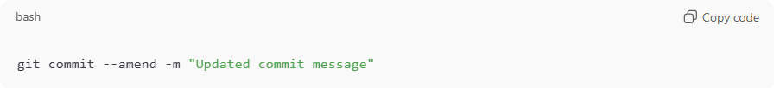
git commit --amend -m "Updated commit message"
2. Amend by adding staged changes
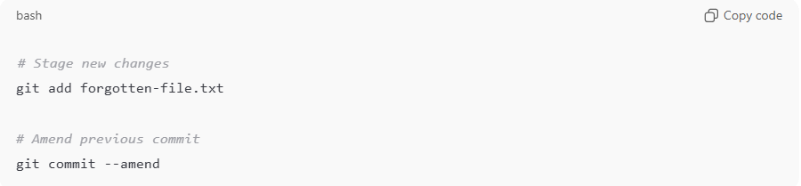
# Stage new changes
git add forgotten-file.txt

# Amend previous commit
git commit --amend
- Opens the editor to optionally change commit message
- Adds the staged files to the previous commit
3. View the change
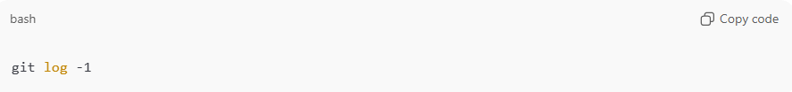
git log -1
- Shows the updated commit as the latest commit

Example Workflow
# Source: AI Source: Provided by: [Data Path: Persons Table -> ID Column: 1, Name_En Column: Motasem Essam] -> From: [ChatGPT] on [2/15/2026]
- Make a commit:
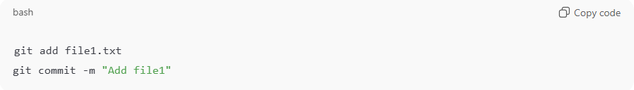
git add file1.txt
git commit -m "Add file1"
- Realize you forgot file2.txt:
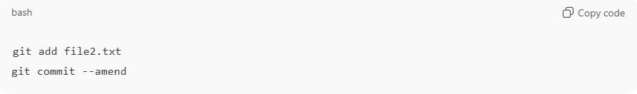
git add file2.txt
git commit --amend
- The new commit now includes file1.txt and file2.txt, and can optionally have a new message.

Analogy
# Source: AI Source: Provided by: [Data Path: Persons Table -> ID Column: 1, Name_En Column: Motasem Essam] -> From: [ChatGPT] on [2/15/2026]
- Regular commit = take a snapshot and save
- Amend commit = fix the snapshot you just took

💡 Memory trick:
# Source: AI Source: Provided by: [Data Path: Persons Table -> ID Column: 1, Name_En Column: Motasem Essam] -> From: [ChatGPT] on [2/15/2026]
Amend = “edit the last commit” → add files or fix the message without creating a new commit ✅

